**Project Report on**

**“SMART WHEELCHAIR FOR PARALYZED”**

A PROJECT REPORT

Submitted by

**KNR18EE024. JASIRA T P**

**KNR18EE034. NAYANA RAMESHAN**

**KNR18EE046. SHRAVAN SREEDEEP**

**KNR18EE048. SOORYA P**

*under the Supervision of*

Dr. C SREEKUMAR

**to**

the APJ Abdul Kalam Technological University

in partial fulfillment of the requirements for the award of the Degree

of

Bachelor of Technology

in

*Electrical & Electronics Engineering*



**Department of Electrical & Electronics Engineering**

**Government College of Engineering Kannur- 670563**

**APRIL 2022**

**ABSTRACT**

Paralyzed stroke patients are unable to normally communicate with their environment. For these patients, the only part of their body that is under their control, in terms of muscular movement, is their eyeballs.

The biggest problem that paralyzed patients face is leading their own life without others support. This include basic day to day operations like switching on basic devices like fan, bulb etc.

An automated working prototype of a smart wheel chair working with a home automation system that can be controlled by eye tracking is implemented in this work. The prototype is designed for the paralysed people with only motor functions for eye movement. This method takes care of surrounding obstructions and decisions are taken accordingly.

**CONTENTS**

|  |  |  |
| --- | --- | --- |
| **TITLE PAGE** |  | **i** |
| **ABSTRACT** |  | **ii** |
| **CONTENTS** |  | **iii** |
| **LIST OF FIGURES** |  | **v** |
| **LIST OF TABLES** |  | **vi** |
| **CHAPTER 1** | **INTRODUCTION** | **1** |
| **CHAPTER 2** | **LITERATURE REVIEW** | **2** |
| **CHAPTER 3** | **WHEELCHAIR DESIGN** | **3** |
|  | 3.1 TECHNICAL SPECIFICATIONS | 3 |
|  | 3.2 CALCULATION OF ROLLING RESISTANCE | 3 |
|  | 3.3 CALCULATION OF REQUIRED POWER | 6 |
| **CHAPTER 4** | **STATUS OF PROJECT WORK** | **7** |
|  | 4.1 COMPONENTS | 7 |
|  | 4.1.1 Raspberry Pi 4 | 7 |
|  | 4.1.2 DC Motor | 8 |
|  | 4.1.3 4 channel relay | 8 |
|  | 4.1.4 Lithium Ion Battery | 9 |
|  | 4.1.5 Adaptor and Connector | 9 |
|  | 4.1.6 Node MCU | 9 |
|  | 4.1.7 Ultrasonic Sensor | 10 |
|  | 4.1.8 Webcam | 11 |
|  | 4.2 ESTIMATION | 11 |
| **CHAPTER 5** | **EXPERIMENTAL SETUP** | **12** |
|  | 5.1 RASPBERRY PI CONFIGURATION | 12 |
|  | 5.2 EYE TRACKING PROGRAM | 13 |
| **CHAPTER 6** | **CONCLUSIONS** | **15** |
| **REFERENCES** |  | **16** |

**LIST OF FIGURES**

|  |  |  |
| --- | --- | --- |
| **No** | **Title** | **Page No** |
| 3.1 | Forces in road inclinations. | 4 |
| 4.1 | Raspberry Pi 4 | 7 |
| 4.2 | DC Motor | 8 |
| 4.3 | 4-Channel Relay Circuit | 8 |
| 4.4 | Batteries | 9 |
| 4.5 | Adapter and Connector | 9 |
| 4.6 | Node MCU | 10 |
| 4.7 | Ultrasonic Sensors | 10 |
| 4.8 | Webcam | 11 |
| 5.1 | Raspberry Pi 4 graphical interface setup | 12 |
| 5.2 | Experimental Setup | 13 |
| 5.3 | Result of Eye tracking program on Raspberry Pi 4. | 14 |

**LIST OF TABLES**

|  |  |  |
| --- | --- | --- |
| **No** | **Title** | **Page No** |
| 4.1 | Estimation of components | 11 |

**CHAPTER 1**

**INTRODUCTION**

The Wheelchair is a dependent system used by elderly and physical disable persons. Here we are introducing the design implementation model of a totally independent Eye controlled electric wheelchair. For a totally paralyzed person it is very difficult to use controller type of electric wheel chair. Here the Eye control system provides the independence to make their life easy and more convenient. And also they save huge amount of energy or external man power.

Camera captured the image in real time and analysis the image as input to set the commands for interface the motor driver IC through sending the commands to GPIO pins. The motor driver circuit is used to perform the different operation such as left, right, forward and stop. For the advance level of Image Processing open computer vision (OpenCV) library is used for Face and Eye detection. Google’s MediaPipe library is used to find out accurate pupil location detection and tracking of that.

An Eye tracking technique, which capture the image and detects the presents of human face. After detecting the face, it detects area of the eye location on the face detected image, and performs several operation of basic image processing like colour image to grey conversion, filtering, threshold, pattern matching, noise reduction and circle detection on it.

The Raspberry pi board is used to perform the control of the complete system operation. Digital Image processing based output signal sent to the Raspberry pi board. The Raspberry pi acquired the data and analyse it. Raspberry pi send the control signal to motor driving circuit based on the location of eye pupil. In a Wheelchair two individual motors are embedded on each wheel. The Ultrasonic sensor is also mounted on the wheelchair for detection of any static or mobile obstacle. If sensor gets the obstacle very close to the wheelchair, it will indicate to the raspberry pi and raspberry sends the signal to motor driving circuit to stop the motor.

**CHAPTER 2**

**LITERATURE REVIEW**

Yi-Chen Lee, Ching-Min Lee [1], research combines Raspberry Pi with the Internet of Things and the foundations of artificial intelligence to develop a real-time smart home surveillance system to improve safety at home. The main method is to connect the Raspberry Pi to a network sharer or computer with a fixed IP and then input it into a computer or mobile phone to achieve remote control. To provide home safety for the elderly or the challenged people, the proposed system combines a voice control module to improve the user convenience. The authors Muhammad Azlan Alim, Samsul Setumin, Anis Diyana Rosli, Adi Izhar Che Ani, [2] proposed a voice recognition-based intelligent wheelchair system for physically disabled people who are unable to control the wheelchair by their upper and lower limbs. This development employs voice command to controls the movement of the wheelchair in different directions. V. Usha Rani, Dr.J Sridevi, P. Mohan Sai, [3], developed a robot that can move to any location within the range of the network and can be accessed globally from anywhere and as it uses only one camera to secure a large area it is also cost-efficient. At the core of the system lies Raspberry-pi which is responsible for all the operation of the system and the size of the device can be engineered according to the area it is to be used.

**CHAPTER 3**

**WHEELCHAIR DESIGN**

**3.1 TECHNICAL SPECIFICATIONS**

During the movement of a wheelchair, there are some resistances that appear. These resistances are variable and depend on various parameters as described below:

• Rolling resistance

• Aerodynamic resistance

• Inertial resistance

In the wheelchair, aerodynamic resistance and inertia resistance are considered insignificant because the accelerations and speeds which are developed on the vehicle are kept to a minimum.

**3.2 CALCULATION OF ROLLING RESISTANCE**

When an unformulated wheel is wrapped in unformed ground or, respectively, a fully resilient wheel is wound on a fully developed ground, there is no resistance to the movement. These are the ideal cases, as in reality both the ground and the wheel suffer from deformations. The developed torque which is created equals to:

*Tr = N*a -----------(1)*

where N is the maximum vertical force in Newtons and a is distance from a theoretical axial line of the wheel in meters. To balance this torque, it is necessary to develop a torque opposite to this. This torque equals the product of the pulling force Fr and the dynamic radius of the wheel. The vertical force (Fz) which expresses the mass of a body in strength equals to:

*Fz = m*×*g -----------(2)*

where m is the body mass and g is the acceleration of gravity. The rolling resistance Fr is described by the following formula:

*Fr = Fz * μr----------- (3)*

where μr is the rolling resistance coefficient which is estimated for the wheelchairs with nonpneumatic wheels on concrete, with the value of μr = 0.015. For the calculation of the wheelchair rolling resistance is taken into account the mass of:

* + Wheelchair, m1 = 7kg
  + User, m2 = 100kg
  + Battery, m3 = 2×2.5kg = 5kg
  + Motor, m4 = 2×2.35kg = 4.7kg
  + Auxiliary weight, m5 = 200g

Total weight in kilogram, M= m1+m2+m3+m4+m5

M= 7+100+5+4.7+0.2 = 116.9kg *≈* 117kg

*Fz = M* ×*g ----------(4)*

*Fz = 117* × 9.81

*Fz = 1147.77 N*

*Fr = Fz*×*μr -----------(5)*

*Fr = 1147.77* × *0.015*

*Fr = 17.2 N*

When climbing a vehicle due to road inclination, a resulting force from the weight of the vehicle appears (Figure 3.1). This force opposes the movement of the vehicle when it is on the hill.

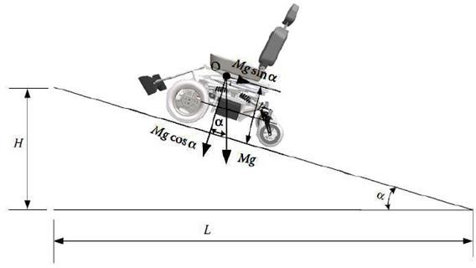

Fig 3.1 Forces in road inclinations.

The ascent resistance FB is calculated from the following formula:

*FB=Fz*Sinα ----------- (6)*

where Fz is vertical force in Newtons and α is the angle of the road inclination. As it is known, the tilt of the road is the ratio of the height H to the distance L (Figure 3.1) and expresses the height to be developed at a distance of 100 km:

*Ι = Η/L = tanα ≈ sinα ----------- (7)*

To find the angle α, in order to calculate the ascent resistance, the right formula is the following:

*Α=tan-1 (i) ----------- (8)*

Thus, for a pavement slope of 10O the vehicle has an ascent resistance equals to:

*FB= 1147.77 × Sin10 = 199.31 N -----------(9)*

Since the forces are opposing to the movement of the vehicle, it is accurate to be summed in order to find the required driving force (traction force) to be applied to the wheels in order to move it.

*Ftotal= Fr + FB = 17.2+ 199.31 = 216.51 N ----(10)*

where Ftotal is the total traction force which is the sum of ascent resistance FB and the rolling resistance Fr . The torque needed on the wheel to overcome these resistors is calculated by the formula:

*Ft = Mk * itot/rt => Mk = Ft*rt / itot ------- (11)*

where Mk is the torque on the wheel in Nm. The rt the radius of the wheel and itot its gear transmission ratio from the motor to the wheel. The motors have a diameter of 12inch (308mm) with a working voltage of 24V, 250Watt and a fixed gear transmission ratio of 23:1. The maximum torque that can be produced by the motor according to its operating diagram is 20Nm and is enough to overcome the climb and roll resistors.

*Ft = Mk* × *itot / rt*

*Mk = Ft* × *rt / itot*

*= 22* × *0.154 / 23*

*= 1.5 Nm*

**3.3 CALCULATION OF REQUIRED POWER**

Work results when a force acts upon an object to cause a displacement (or a motion) or, in some instances, to hinder a motion. Three variables are of importance in this definition - force, displacement, and the extent to which the force causes or hinders the displacement. Each of these three variables find their way into the equation for work. That equation is:

*W=F*χ ----------- (12)*

where W is the work in Joules, F is force in N and χ is the displacement in meters.

Considering the above mathematical formulas and knowing the velocity it follows that:

*P = Ft*Vt -----------(13)*

where P is the power in watts Ft is the traction force in N and Vt is the velocity in m/s. Theoretically, the power given to the vehicle, when it moves at the maximum speed (3.54m/s) it can develop (considering only the rolling resistance):

*P = 17.7N * 3.54 m/s = 62 Watt ------(14)*

The needed energy to drive the vehicle for one hour is calculated by the formula:

*E= P*t => E = 0.062KWh -------- (15)*

where E is the energy in KWh, P is power in watt and t is the time in hours According to the formula below, the vehicle needs 2.58Ah to move one hour at maximum speed.

*E = Qx*V/1000 => Qx=0.062*1000/24 => 0.062*1000/24 = 2.58Ah ------(16)*

Where E is the energy needed in Ah, Qx is the capacity of the battery in Ah and V is the voltage of the battery used in the experiment equal to 24V.

**CHAPTER 4**

**INTERNAL ARCHITECTURE**

**4.1 INTRODUCTION**

In this system it is mandatory to gives the proper power supply to individual components, and the standard power supply should be used for Raspberry Pi, Arduino, camera, sensors, and motors. The Raspberry Pi board is the brain of the wheelchair. Here the modules like camera, motor driver and voice output device are directly connected to the Raspberry Pi board. And Raspberry Pi board is connected to the internet for remote access facility through Wi-Fi. In case, emergency controlling or monitoring the status of wheelchair, will be carried out by accessing the Raspberry Pi board at remote place using web-server (internet). Our system can be divided in to four parts, namely controller, programme, wheelchair and home automation.

**4.2 CONTROLLER**

Raspberry Pi is the main controller of our prototype. It gives commands to the motor driver circuit, which enables the GPIO pins to perform several operations, such as forward, left, and right on the basis of eye ball movement.

For real time video capturing and advanced image processing, a 8 MP web camera is used. It is very challenging to detect the exact eye pupil location, so a new image processing technique is used for eye pupil centre detection and tracking, which works based on open computer vision (OpenCV) library. Most of the coding part is done with the help of OpenCV library. Google’s MediaPipe library is used to find out accurate pupil location detection and tracking of the same. Python language is used for coding, which is user friendly and helpful to resolve the errors efficiently.

First camera module will start to capture the images. For the face detection mediapipe library is used. After detection of proper face, it will trying to detect the eye inside the face region of interest. And again, mediapipe library is used to detect eye. It will draw the rectangular box over the eye. Now, the main target is to detects the eye pupil and define its centre points. There are several image processing operations performed in system, such as blur Image, colour conversion, thresholding, filtering, edge detection and Hough transform is used. For circle detection Hough transform method is used. By the usage of USB webcam, images are captured on Raspberry Pi. OpenCV library is installed in Raspberry Pi memory.

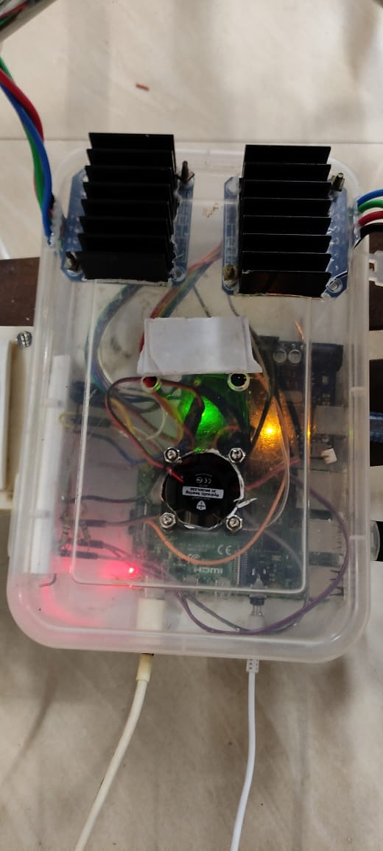

Fig 4.1 Controller

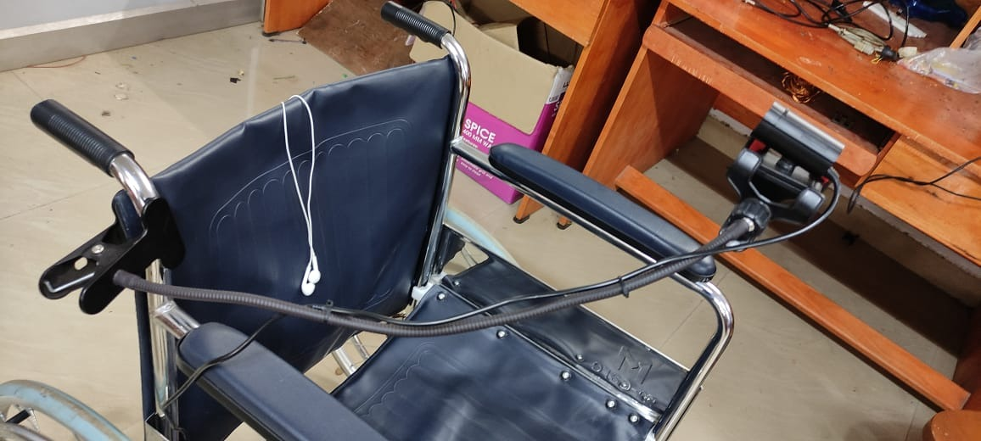

Fig 4.2 Webcam arrangement in wheelchair

**4.2.1 Raspberry Pi 4**

Raspberry Pi 4 Model B is the latest product in the popular Raspberry Pi range of computers is shown in the fig 4.1. It offers ground-breaking increases in processor speed, multimedia performance, memory, and connectivity compared to the prior-generation Raspberry Pi 3 Model B+, while retaining backwards compatibility and similar power consumption. For the end user, Raspberry Pi 4 Model B provides desktop performance comparable to entry-level x86 PC systems. This include a high-performance 64-bit quad-core processor, dual-display support at resolutions up to 4K via a pair of micro-HDMI ports, hardware video decode at up to 4Kp60, up to 8GB of RAM, dual-band 2.4/5.0 GHz wireless LAN, Bluetooth 5.0, Gigabit Ethernet, USB 3.0, and PoE capability (via a separate PoE HAT add-on).

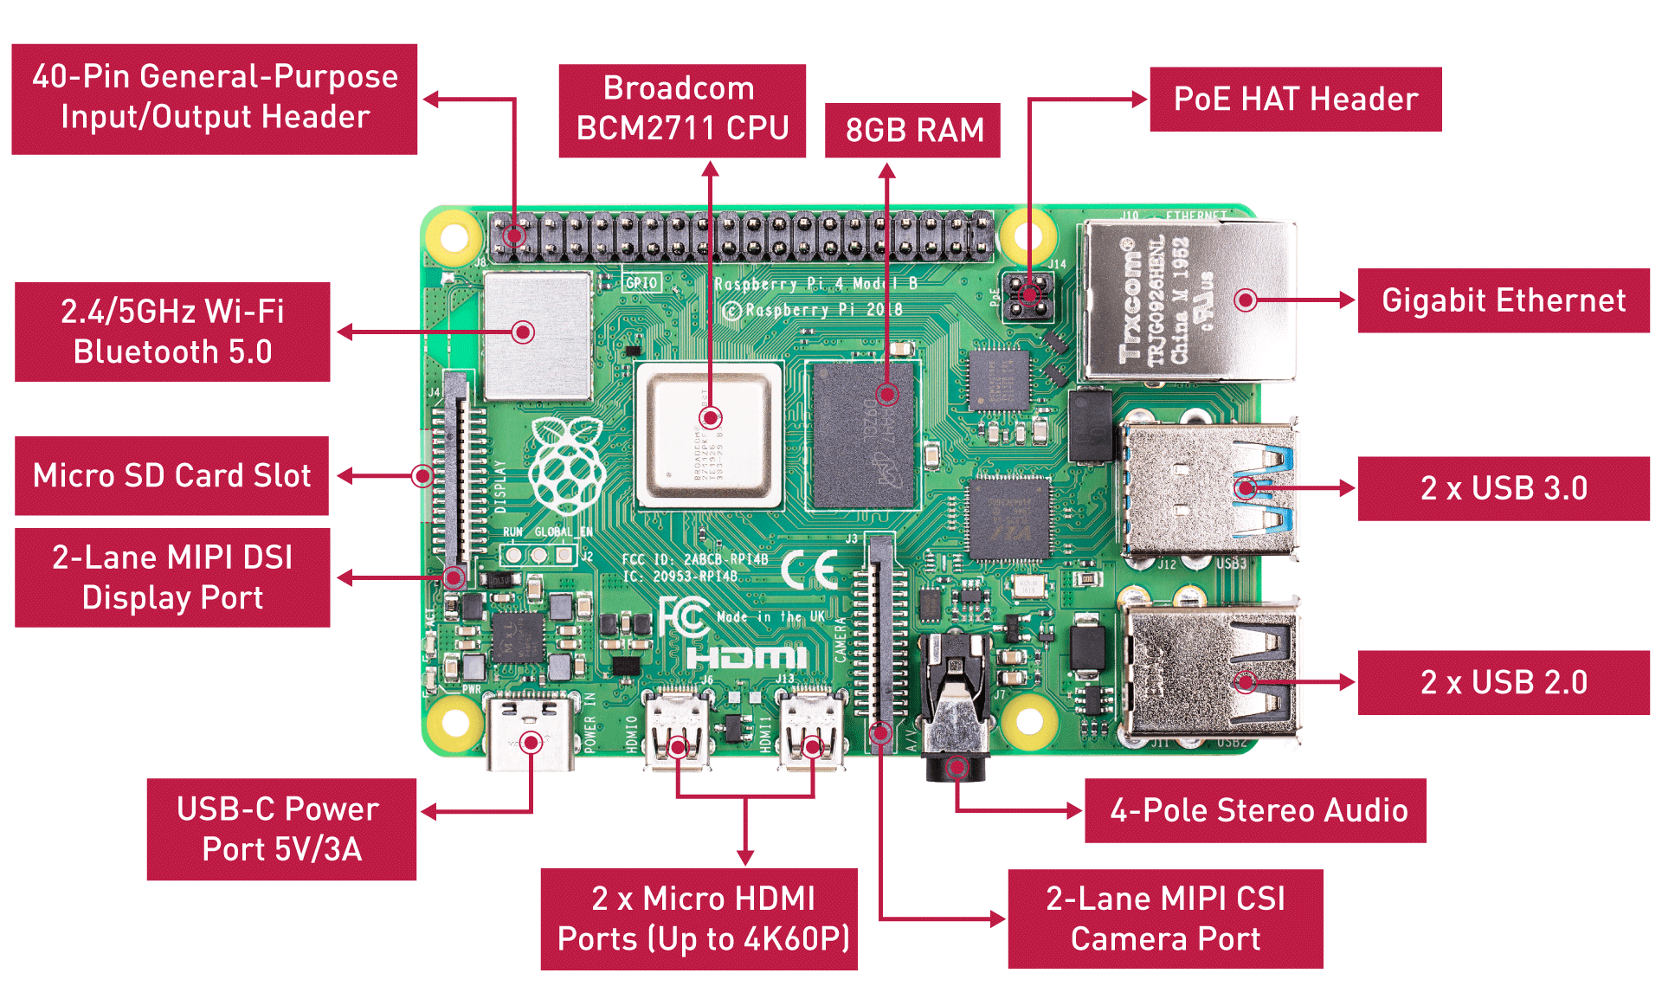

Fig 4.3 Raspberry Pi 4

**4.2.2 Webcam**

The webcam is a video camera that feeds or streams an image or video in real time to the Raspberry Pi 4 in order to track the eye movements. The Webcam is connected to Raspberry Pi 4 using USB port.

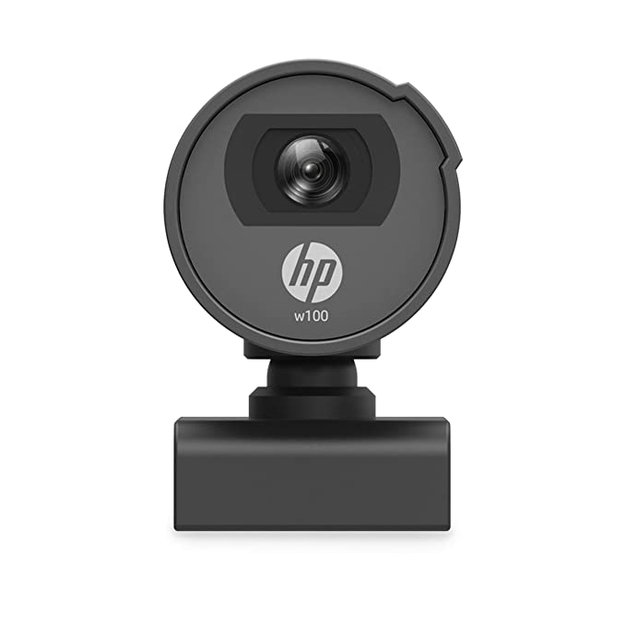

Fig 4.4 Webcam

**4.3 PROGRAM**

The basic function of this program is eye tracking and detection of eye movement. To detect the location of eye pupil Haar cascade algorithm is used this technique comprises of several stages which are implemented to find the eye movement and also for face and eye detection, color switching, object tracking, Hough transform, edge detection and motion detection.

Initially system captures image by making use of webcam. First step is the algorithm accurately detects the face of the user. According to the algorithm the system represents the user face in specific area of indicated image. Several process of image processing techniques is performed for eye pupil tracking. Primarily camera module captures image, face is detected using mediapipe library which use Haar cascade algorithm. Once the face is detected it detects eye inside the face region rectangular boxes are drawn across eye once it is detected. Now detection of eye pupil and definition of pupil center point is need for doing this several image processing techniques like color conversion/switching, edge detection, blur image, filtering, Hough transform and thresholding is implemented, for detecting circular shapes Haugh transform is implemented, with the help of webcam, images are captured and transferred to Raspberry Pi. OpenCV library is installed to Raspberry Pi which supports the image processing technique.

To find out the pupil centre point of the Eye, we followed some steps:

**4.3.1 Face Detection and Eye Detection**

For the face detection and eye detection the OpenCV library is used directly. A system camera detects the face of user. Once it will detected, system finds the eye location and marks the eye region using Mediapipe library. And system accurately detect both the eyes based on the proper distance of the each other.

**4.3.2 BGR To Gray Conversion**

A very next operation of the image color convention to reduce the system delay time. The Image frame size should be low, because the processor cannot processing the image frames in run time condition. So, by using the BGR to GRAY conversion a colored image converted into gray image.

**4.3.3 Features Detection and Blurring Image**

The Gaussian blur filter is used for blurring the image. Which helps to detect the exact edges

of specific area of the cropped image. Features is nothing but it found some special pattern on

image which is unique, based on it will make a pattern.

**4.3.4 Edge Detection**

A canny Edge detection and corner edge detection algorithm is applied for determine the soft

edges of the image. To set the proper threshold value it will allowed easy to recognize

rectangles or circle presented in Image.

**4.3.5 Eye Tracking**

To track the Eye movements we use projection function algorithm was used, where the

coordinates system points the eye centre point location. In Fig 4.1 indicates the eye pupil

location with respective coordinate’s system graph.



Fig 4.5 Coordinates system with respective eye position

**4.4 WHEELCHAIR**

An ordinary wheelchair is converted to electric wheelchair with the help of 250W 24V DC motors, BTS7960 motor drivers, and 12V 7.2Ah rechargeable lithium-ion battery. The motor drives the wheels with the help of chain and sprocket arrangement as shown in fig 6

The complete arrangement of the converted wheelchair is shown in fig7 and fig.8

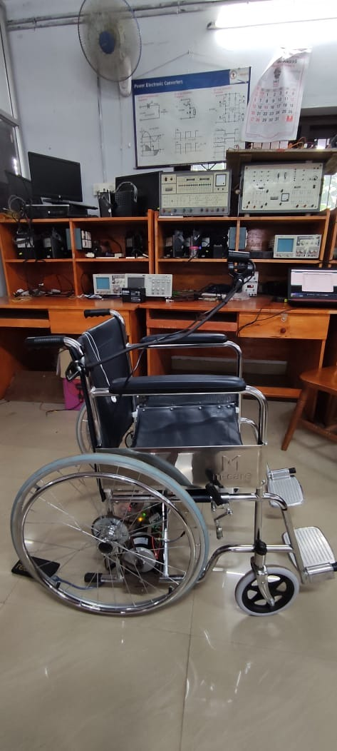

Fig 4.7 Side view of wheelchair

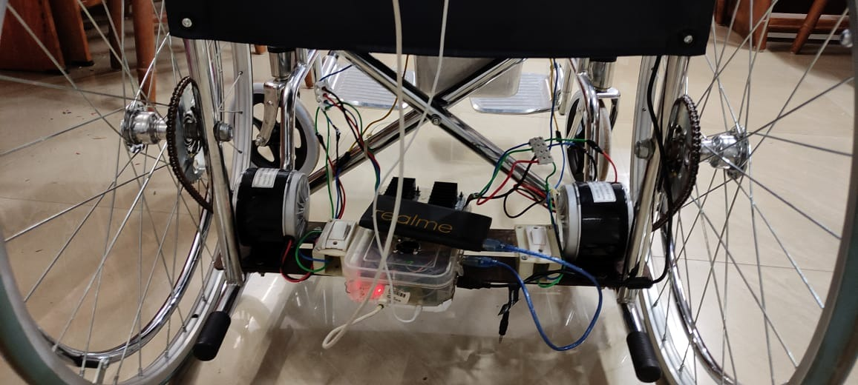

Fig 4.8 Conversion setup

The specification and working of each component are provided below.

**4.3.1 Wheelchair**

Due to practical difficulties for the conversion of wheel chair to electric wheelchair, the folding mechanism is neglected and cannot be relied on the converted wheelchair.

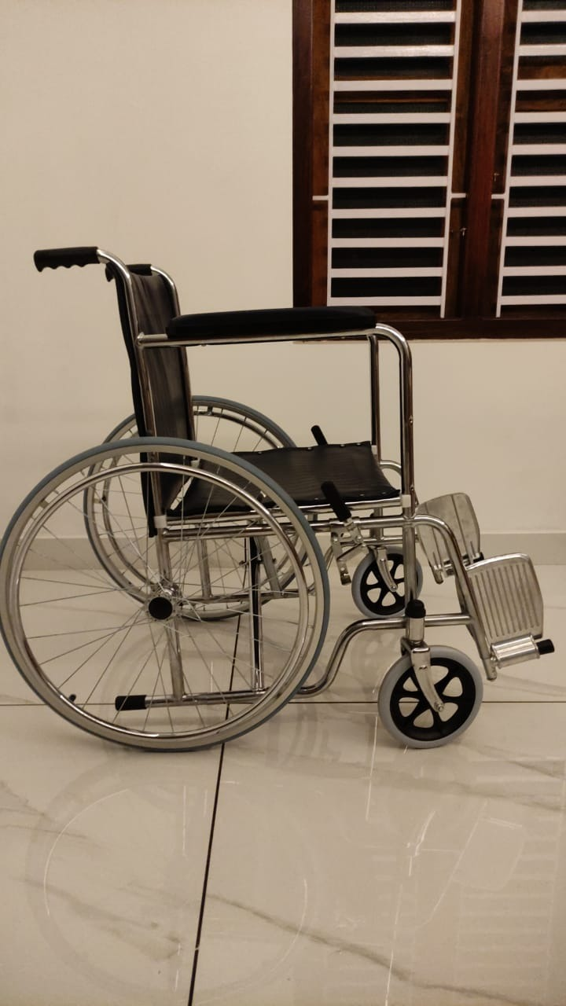

Fig 4.9 Side view

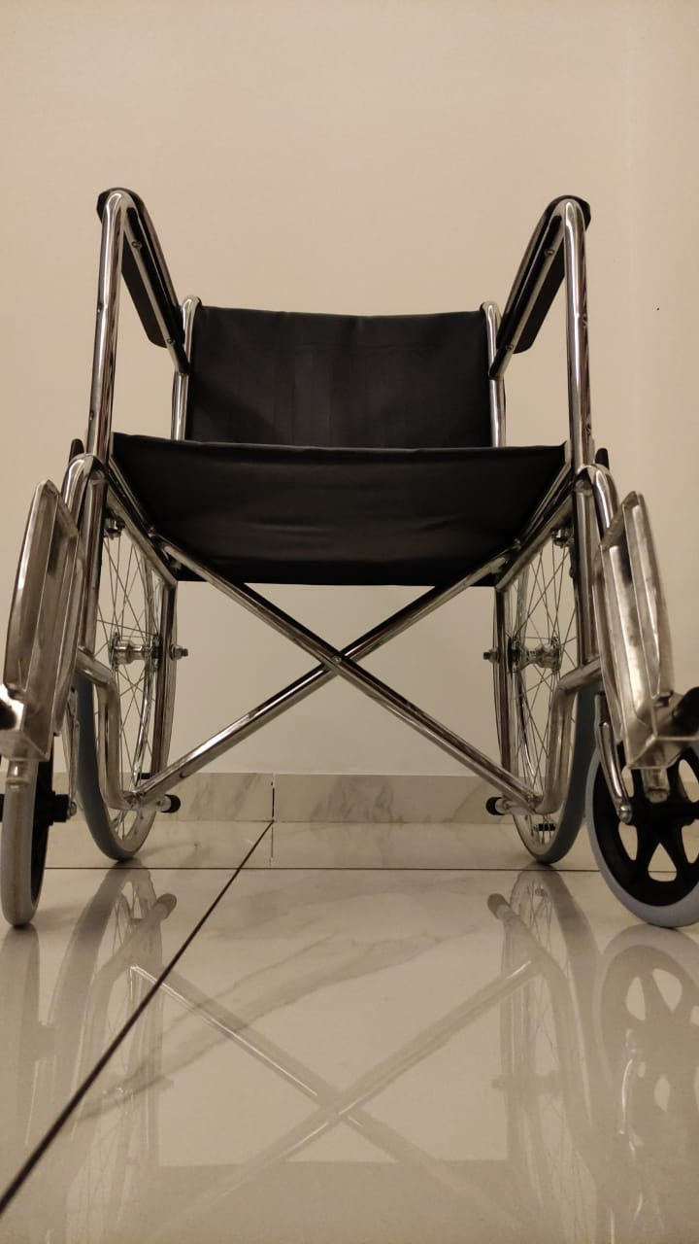

Fig 4.10 Front view

**4.3.1 DC Motor**

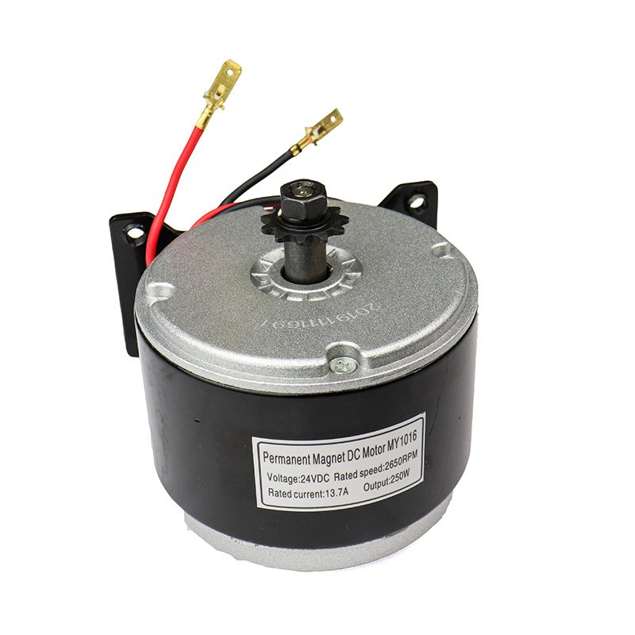

Fig 4.11 DC Motor

MY1016 250W 24V 2650RPM DC motor has 11-tooth, 4-bolt mounting bracket (threaded M6) on the base. As this is a DC motor it is capable of rotation in either the clockwise or counter clockwise direction by just reversing the battery polarity to the motor and can be speed controlled. It has an operating power of 250W, operating voltage 24V, rated current in the range of 9A to 11A and having a speed of 2650rpm. This motor is shown by fig 4.2 given below.

**4.3.2 Lithium Ion Battery**

The figure 4.4 shows 12V 7.2Ah rechargeable lithium ion battery. Each battery weights 2.4kg. The battery is capable of providing power to the motors to carry a load up to 100 kg for 20 mins.

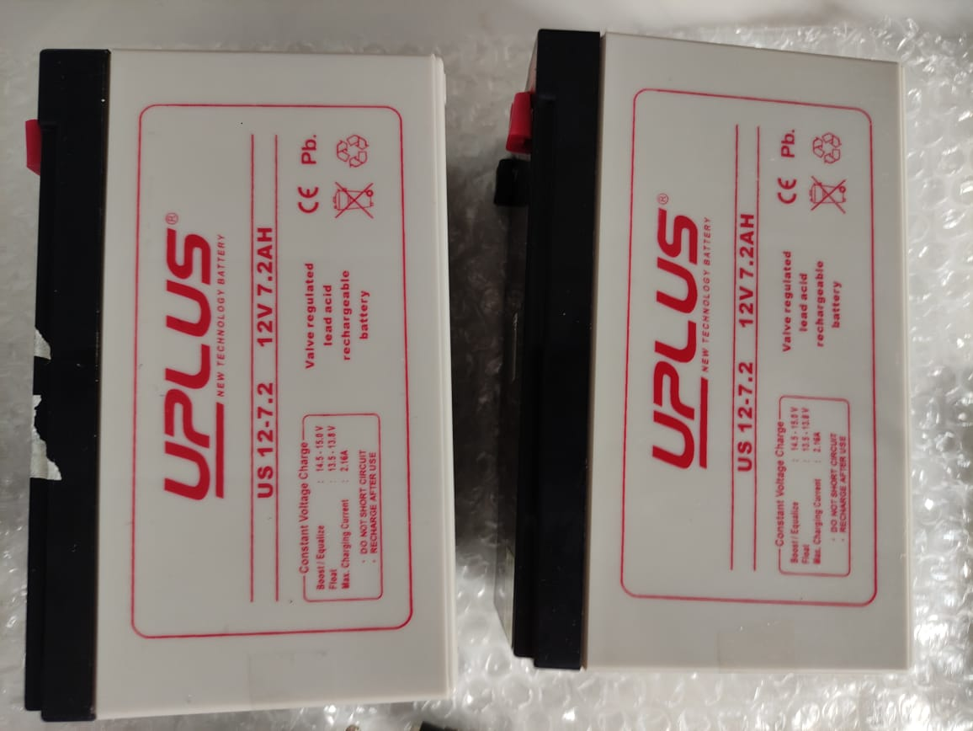

Fig 4.12 Batteries

# 4.3.4 H-Bridge High-Power Stepper Motor Driver Module

# The Double BTS7960 43A H-Bridge High-Power Stepper Motor Driver Module is a fully integrated high current H bridge for motor drive applications using the BTS7960 high current half bridge. It has the PWM capability of up to 25 kHz combined with active freewheeling and Switched mode current limitation for reduced power dissipation in overcurrent.

# Double BTS7960 43A H-Bridge High-Power Stepper Motor Driver Module

Figure 4.13 Motor Driver Module

Arduino Uno provides the necessary PWM and polarity signals for speed and direction control of the motors.

# 4.3.5 Cooling Fan for Raspberry Pi

A 5V Cooling Fan finds its use as an exhaust fan on the [Raspberry pi case](https://robu.in/product/raspberry-pi-4-black-compact-abs-case/) as well as 3D printers. It maintains the temperature of the extruder, which results in smooth printing. The cooling fan operates on 0.2A 5V DC power supply which can be easily powered from RPI board. It has a 2 pin JST connector to easily connect to the printer controller system, and provide hassle-free operation. The fan is made of plastic and is light-weight. It is noiseless as well.

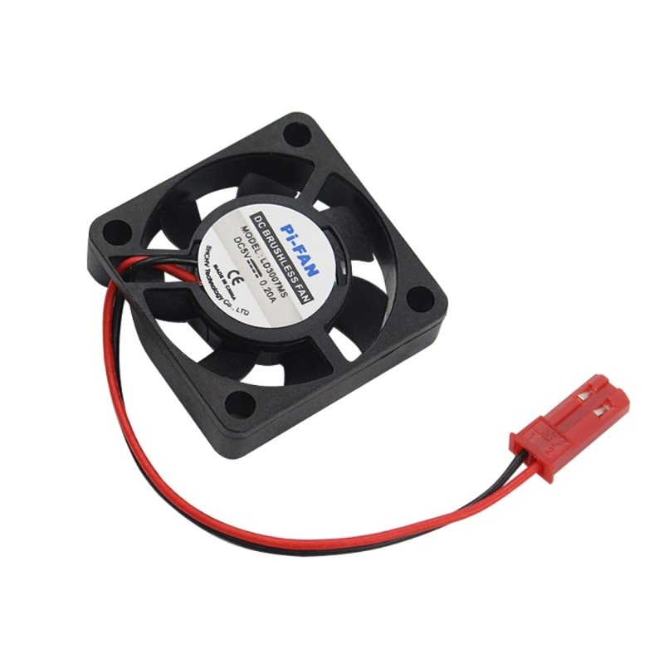

Fig 4.14 Cooling Fan

The fan is connected to the 5V power supply from Arduino UNO and is powered on when the system turns on.

**4.5 HOME AUTOMATION**

The circuit for the home automation system is shown in fig. 4.15 The 3-pin plug provided in the circuit is used to connect the adaptor of the Node MCU. The system can be controlled both using eye tracking and with the help of the webserver hosted in the Node MCU in its local network. The interface of the webpage in the webserver is shown in fig. 4.16

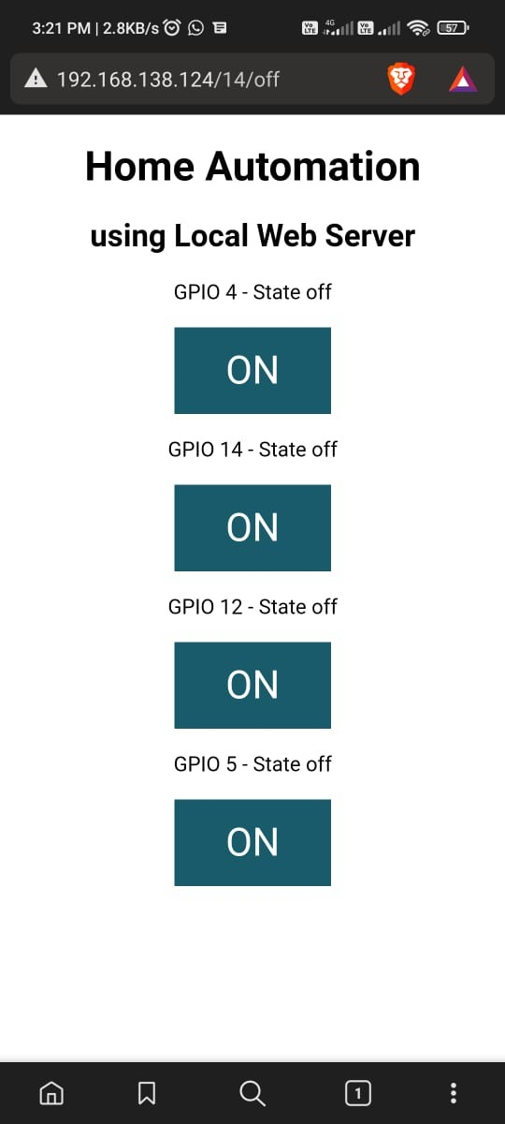

**4.4.1 Node MCU**

ESP8266 Node MCU has powerful on-board processing and storage capabilities that allow it to be integrated with the sensors and other application-specific devices through its GPIOs with minimal development up-front and minimal loading during runtime. Its high degree of on-chip integration allows for minimal external circuitry, and the entire solution, including the front-end module, is designed to occupy minimal PCB area.

This Wi-Fi development board already embeds in its board all the necessary components for the ESP8266 (ESP-12E) to program and upload code. It has a built-in USB to serial chip upload codes, 3.3V regulator, and logic level converter circuit so you can immediately upload codes and connect your circuits.

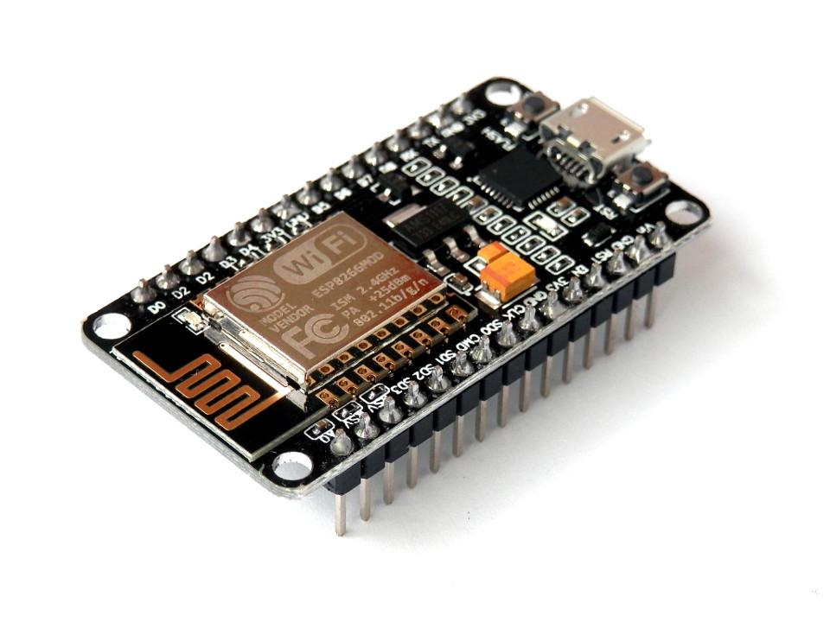

Fig 4.6 Node MCU

It also runs a webserver to control the relay circuit with the devices in the same local network.

**4.4.2 Four Channel Relay**

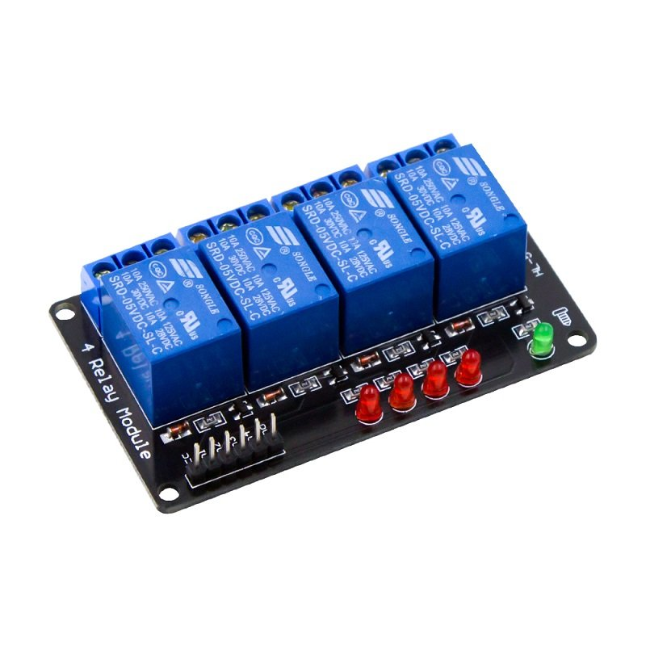

Fig 4.3 4-Channel Relay Circuit

The figure 4.3 shows 4-Channel Relay interface board and each one needs 15-20mA Driver Current. It can be controlled directly by Micro-controller with 5V input voltage.

**4.6 ESTIMATION**

Table 4.1 Estimation of components

|  |  |  |  |
| --- | --- | --- | --- |
| **SL**  **No.** | **Component Name** | **Quantity** | **Price** |
| 1 | Wheelchair | 1 | 7000 |
| 2 | 250W, 24V, 13.7A Motor | 2 | 5000 |
| 3 | 4 Channel Relay | 1 | 250 |
| 4 | 12V, 7.2Ah Battery | 2 | 1500 |
| 5 | 15V,2.2A Battery Charger | 1 | 250 |
| 6 | Node MCU | 1 | 500 |
| 7 | Ultrasonic Sensors | 4 | 400 |
| 8 | Earphone | 1 | 400 |
| 9 | Raspberry Pi 4 | 1 | 5100 |
| 10 | Webcam | 1 | 1500 |
| 11 | BTS7960B Bridge Motor Driver | 2 | 1600 |
| 12 | 5V 0.2A 3007 Cooling Fan | 1 | 220 |
| 13 | Sprocket and chain | 2 | 550 |
| 14 | Tripod | 1 | 200 |
| 15 | Miscellaneous |  | 500 |
| Total Cost | | | 24970 |

**CHAPTER 5**

**PROTOTYPE**

**5.1 INTRODUCTION**

In this model as shown in figure() a wheelchair prototype is designed and implemented that contains Raspberry Pi, Arduino, Node MCU, Relay module, battery, motor etc. Raspberry Pi is programmed for three modes. Voice output is implemented in Raspberry Pi, in order to identify the mode selected. A web interface is hosted in Node MCU in order to control switches in real time other than eye control.

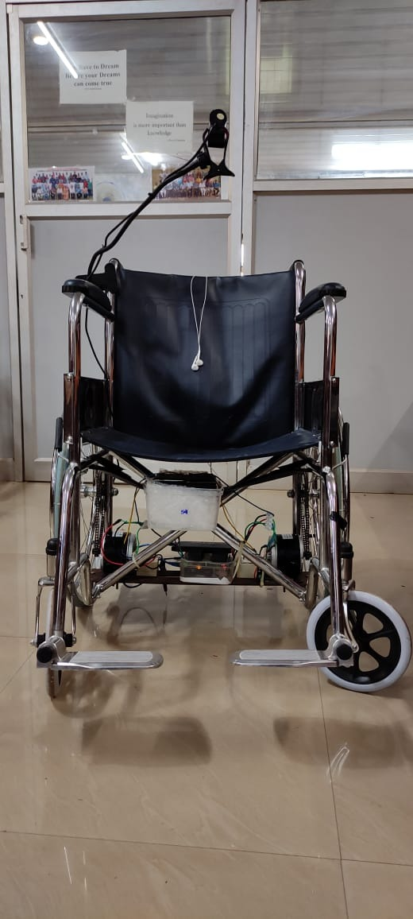

**CHAPTER 6**

**CONTROL AND WORKING OF THE PROTOTYPE**

**6.1 INTRODUCTION**

The proposed system has the following three modes of operation on the basis of number of blinks made by the eye. They are listed below.

**6.2 MODE 1: FIRST DEVICE**

Mode 1 gets selected at 2 blinks. When this mode is selected, and automated text to speech audio output is played in the voice output device which reads out the text “Mode 1 selected” and will help the user to identify the mode selected. In this mode, we will be able to control the first device which is a bulb in this prototype. When the eyeball moves towards the right side, the device will be turned ON, and similarly when it moves to the left side, the device will be turned OFF. Similarly, any other device that can be turned on and off with the help of a switch can be connected to the relay circuit and operated with the help of the prototype.

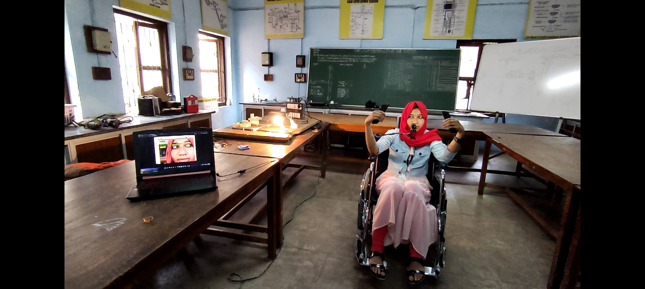

**6.3 MODE 2: SECOND DEVICE**

Mode 2 gets selected at 4 blinks. When this mode is selected, and automated text to speech audio output is played in the voice output device which reads out the text “Mode 2 selected” and will help the user to identify the mode selected. In this mode, we will be able to control the second device which is another bulb. When the eyeball moves towards the right side, the device will be turned ON, and similarly when it moves to the left side, the device will be turned OFF and just as in Mode 1, any other device that can be turned on and off with the help of a switch can be connected to the relay circuit and operated with the help of the prototype.

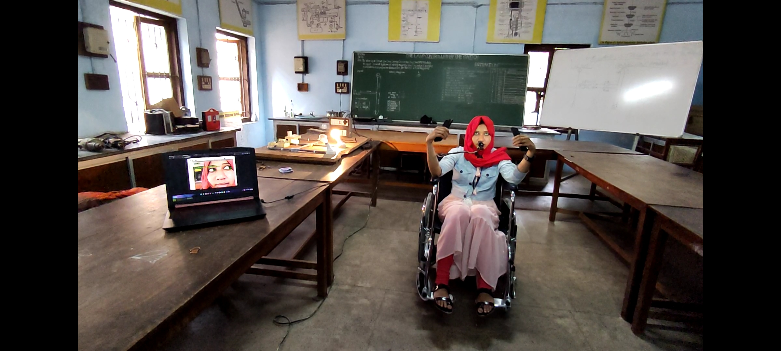

**6.4 MODE 3: WHEELCHAIR**

Mode 3 gets selected at 6 blinks and till 9 blinks. When this mode is selected, and automated text to speech audio output is played in the voice output device which reads out the text “Mode 3 selected, wheelchair control is turned on” and will help the user to identify the mode selected. In this mode we will be able to control the wheelchair. When the user looks down, both the motors rotate in the clockwise direction and the wheelchair moves forward. To move the wheelchair in left direction the user has to look to left side, then its left motor will rotate in anticlockwise direction and the right motor rotates in clockwise direction and the wheelchair moves in left direction. To move the wheelchair in right direction, the user has to look to right side, then its right motor rotates in anticlockwise direction and the left motor moves in clockwise direction, so the wheelchair moves in right direction. When the user looks up or center, both the motor gets turned ‘off’ and the wheelchair stops.

After the blink counts above 9 blinks, the count resets and starts counting again from zero where the whole process is carried out again.

**CHAPTER 7**

**CONCLUSION**

Paralyzed stroke patients are unable to normally communicate with their environment. The biggest problem that paralyzed patients face is leading their own lives without the assistance of others. As a solution to this problem, a smart wheel chair working with a home automation system that can be controlled by eye tracking is implemented.

The eye tracking model is developed in python language using Opencv and mediapipe libraries. Eye tracking technique, captures the image and detects the presence of human face. It detects the location of the eye on the face and conducts basic image processing operations such as colour image to grey conversion, filtering, threshold, pattern matching, noise reduction, and circle detection on it after recognizing the face.

Raspberry Pi 4 is used as the base controller. The Raspberry Pi board is utilized to control the entire operation of the system. It generates signals based on digital image processing. The data is collected and analysed using the Raspberry Pi. Based on the location of the eye pupil, the Raspberry Pi sends a control signal to the Arduino which in turn sends the appropriate signals motor driving circuit. A normal wheelchair is modified to electric wheelchair with two separate motors that are placed in each wheel. The motors are coupled to the wheelchair using chain and sprocket. The wheelchair also has an ultrasonic sensor for detecting any stationary or moving obstacles. If the sensor detects an impediment that is quite close to the wheelchair, it will alert the Arduino Uno, which will send a signal to the motor driving circuit to turn off the motor. Different modes selected on the basis of blink count is used to control home automation system and the wheelchair movement.

**REFERENCE**

1. **Ahmad F. Klaib, Nawaf . Alsrehin, Wasen Y. Melhem, Haneen . Bashtawi, Aws A. Magableh**. “Eye Tracking Algorithms, Techniques, Tools, and Applications with an Emphasis on Machine Learning and Internet of Things Technologies”, September 2020
2. **Pramodini A. Punde, Dr. Mukti E. Jadhav, Dr. Ramesh R. Manza**, “A study of Eye Tracking Technology and its applications”, *IEEE* 2017
3. **Tan Kian Hou, Yagasena and Chelladurai**“Arduino based voice controlled wheelchair”, 2020
4. **Mohammed Hayyan Al Sibai, Sulastri Abdhul Manap**, “A Study on Smart Wheelchair Systems”, *Research Gate* Dec 2015
5. **Deepak Kumar, Reetu Malhotra, S R Sharma**, “Design & Construction of a Smart Wheelchair”, *Science Direct* 2019
6. **Georges Boustany, Alaa El Deen Itani, Rayan Youssef, Omar Chami, Ziad O. Abu-Faraj**, “Design and Development of Rehabilitive Eye-Tracking Based Home Automation System”, *IEEE* 2016
7. **Joseph K George, Subin K B, Arun Jose, Hima T**, “Eye Controlled Home-Automation For Disables”, *IOSR-JEEE* 2017
8. **Deepak Kumar Lodhi, Prakshi Vats, Addala Varun, Prashant Solanki, Ritakshi Gupta1, Manoj Kumar Pandey, Rajat Butola**, “Smart Electronic Wheelchair Using Arduino and Bluetooth Module”, *IJCSMC* May 2016
9. **Airi Ishizuka, Ayanori Yorozu and Masaki Takahashi**, “Driving Control of a Powered Wheelchair Considering Uncertainty of Gaze Input in an Unknown Environment”, *MDPI*, 2018
10. **Mohammed Hayyan Al Sibai and Sulastri Abdul Manap**, “A Study on Smart Wheelchair Systems”, *International Journal of Engineering Technology and Sciences*, 2015
11. **Mohammad A.Eid, Nikolas Giakoumidis and Abdulmotaleb EL Saddik**, “A Novel Eye-Gaze-Controlled Wheelchair System for Navigating Unknown Environments: Case Study with a Person with ALS”, *IEEE Access*, 2016
12. **Yi-Chen Lee, Ching-Min Lee**, “Real-Time Smart Home Surveillance System of Based on Raspberry Pi”, *IEEE Access*, 2020
13. **Muhammad Azlan Alim, Samsul Setumin, Anis Diyana Rosli, Adi Izhar Che Ani**, “Development of a Voice-controlled Intelligent Wheelchair System using Raspberry Pi”, *IEEE Access*, 2021
14. **V.Usha Rani, Dr.J Sridevi, P. Mohan Sai**, “Web Controlled Raspberry Pi Robot Surveillance”, *IEEE Conference*, 2021
15. **Diksha Raj, Anish Kalra, Sreejith Krishna N, Suhriday Roy, Dr. Shreenath K N**, “Wagon - The Smart Wheelchair”, JETIR, August 2021, Vol.8, Issue 8
16. **Dola Das, Prottoy Saha and Nawshin Tabassum**, “Real Time Distance and Mobility Detection of Obstacles Using a Smart Multisensor Framework for Visually Impaired People”, IEEE, 2020